Year 10 Parental Survey

“Year 11 Exam preparation”

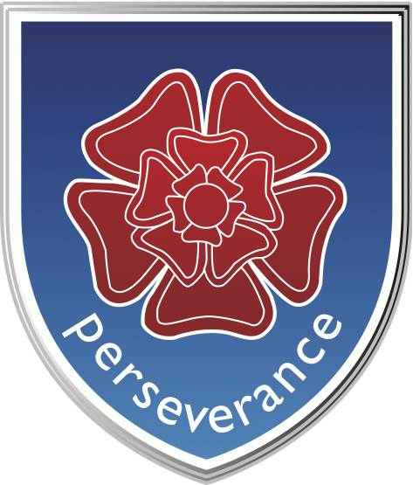

June 2019

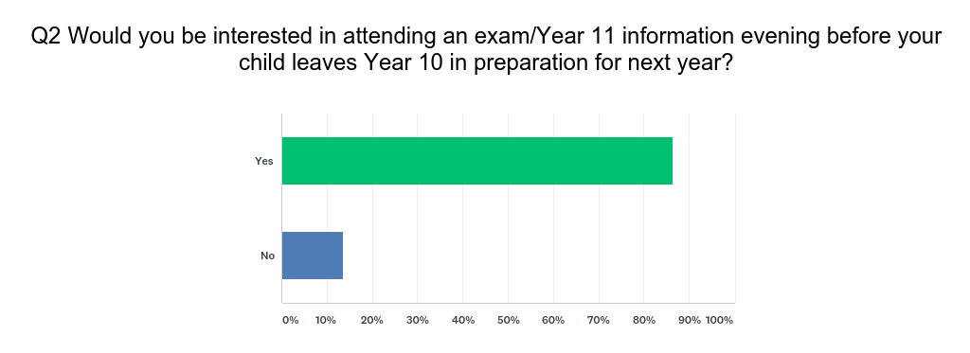

The response to this question was 85.9% positive and demonstrates a clear desire from parents of pupils at Penketh High School to fully engage with discussions around expectations for Year 11, key dates, exam preparation and revision.

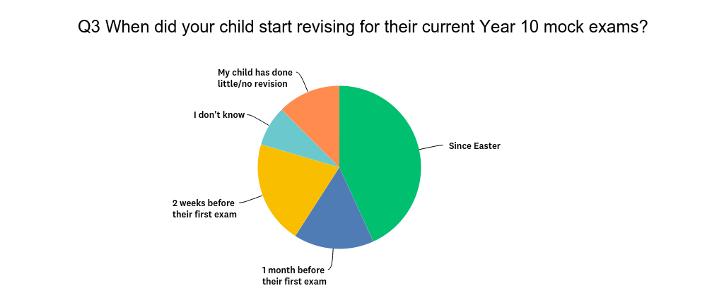

One key message we need students to understand is that revision is not something that is done just before exams. In order to fully embed knowledge and ideas into our long term memory, we need to constantly revisit ideas and concepts over a longer period of time. Little and often is the key to retaining information.

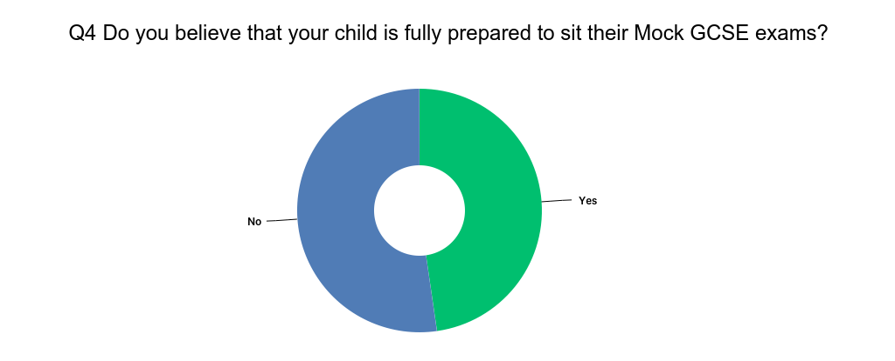

This response shows that over half of the people who responded are concerned that their child is not fully prepared to sit their Year 10 mock exams. If we compare this to the same question asked to Year 11 parents there is a clear difference.
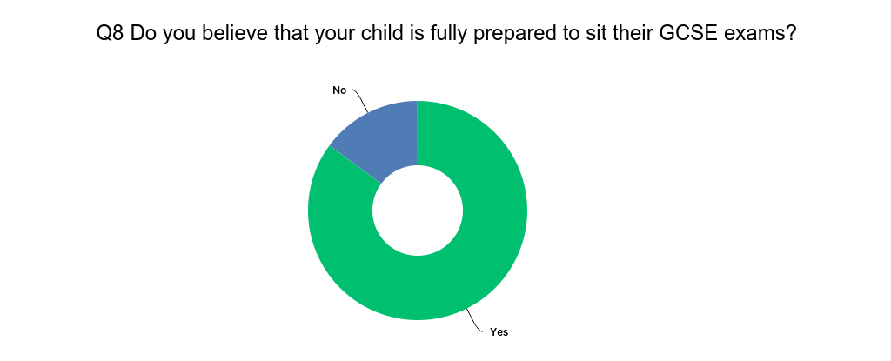

Your child will have mock exams again in November/December. We as staff and parents need to make young people understand the value of mock examinations. Fully preparing for mock exams not only helps with long term memory retention but also allows teachers to gain a better picture of what areas need to be further developed and taught to help your child achieve the best results possible in August 2021.
If your child waits until April/May next year to start revising they will find it almost impossible to retain any information as they will almost certainly just be ‘cramming’ for the exams which does not work.
Mock exams are also a great way to trial various revision techniques. Using a variety of methods such as flashcards, mindmaps, revision clocks, post-its etc will allow your child to figure out which methods work best for them.
2 things that DO NOT WORK are just reading notes or books and copying out notes word for word. These things are proven to be almost a waste of time!

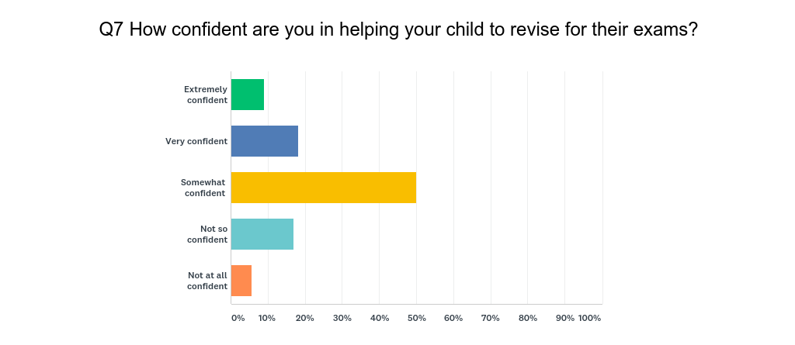
The information shown here demonstrates a need for us as a school to support and guide many parents and families. We will be with you every step of the way and are always just a phone call or email away. Here are five simple parent tips to think about.
Establish effective study habits
Help your child create a study plan early on (this will make you aware of their exam dates too), making sure it is realistic and achievable to avoid de-motivation. Planning in advance will also help avoid ineffective cramming sessions further down the line. Encourage them to use a weekly planner so they are accountable for their work. Don’t micro-manage. Provide extra support if they need or ask for it.
Take a break!
Don’t try and force them to work for hours at a time. Their concentration span is limited and it will hinder the success of their revision if they are trying to do mammoth sessions. Suggest the use of a timer as well as regularly changing revision subject, to avoid getting stuck in a rut.
Practise past papers
Past papers encourage your child to think contextually, rather than just trying to memorise an entire text book. You can help by creating a realistic, timed, exam scenario when they are completing practice papers .This will encourage them to get used to working under pressure and develop exam strategies, helping them feel less anxious on the day.
Watch for signs of frustration
It’s important that your child is in the right frame of mind for revising. If they are struggling over something in particular, it may be best to park it for the night, reassess the next day and break it down into manageable chunks. Be sure to ask them how their exam went, then shift their focus to what’s coming up next and encourage them to say in a positive mind-set.
Ask for help
If you are working closely with your child to help them study, but feel the work is beyond your own skill set, it may be worth seeing if there is another family member who can assist. Or, if you feel this may be a long term issue and your child needs extra support, it may be worth hiring a private tutor to help improve your child’s understanding of the subject.
You said | Our response
I think pupils should have opportunity to attend subject support at lunchtime to clear up anything they may be struggling with as nights are spent revising. | Unfortunately we can’t offer this as staff are on duty at lunch or running enrichment clubs or having their own lunch but Year 11 will have EPS sessions throughout the year and you will be kept informed of when these are and for which subjects.
No updates from school on how he is doing and what to prepare for unless ***** has this and hasn’t shared. I would also love some guidance please on an exam revision strategy. Thank you.  More feedback from my child's teachers as to how well my child is doing in class  Parents need to be advised of how their children are doing before the exam and advise us how to help them in their weak areas | We will make sure that you get a full breakdown of the results from these Year 10 mock exams and the mock exams in Year 11. Where a student needs extra support we will endeavour to contact parents as a matter of urgency.  In terms of exam revision strategies this will be shared with parents as well as students and we will have several parental evenings to keep you fully in the loop.
I pay for private tutorial for my daughter as I don't think she could pass without it | A tutor can be a fantastic resource and can offer your child that 1-1 interaction that can be vital to consolidate learning from the classroom. It should not be seen as a negative to ‘have to get a tutor’ but an as an extra support mechanism if it is a possibility for you as a family. We have many current year 11 students who have had tutors and where there is effective communication between parents, school and tutors the progress can be rapid.
Although ***** has done a little revision, she’s under the impression that a couple of weeks prior to an exam is a good time to start ! | The message will be clear – revision is a yearlong process and needs to be so to activate the long term memory. We will work with your children to ensure that they feel comfortable and able to revise using a range of strategies. If you are ever worried about how much revision they are (or are not) doing or that they are saying they don’t know how or what to revise please get in touch immediately.
In year 9 she had 5 history supply teachers. An art teacher for LfL and a Spanish supply for the first term and a half | Unfortunately, as with any industry or workplace, any school will always have some absence or employees who leave for a different job. This is often coupled with a general and national shortage of teachers in certain subjects. Going into next year we are fully staffed in all departments with specialists in each and every department. Where staff are off long term we will always ensure that the impact of this does not affect Year 11 in their final and crucial year of study.
Could have more after school clubs to prepare now and not just next year when they have to sit them for real  I think a good idea for the year 10 mocks would be to have them attend EPS style sessions so that the year after they are aware of what they can do in the sessions but also help those that do struggle for that extra year of revision may help them learn how to better revise when at home | In an ideal world we would also agree. However our staff have to prepare Year 11 for their exams and, therefore, are not able to offer this to other years.  After school sessions, holiday sessions, Saturday sessions are all delivered outside of a teacher’s normal working hours and they do not get paid for these. However, we are very fortunate at Penketh High to have a hugely committed staff who want nothing more than the very best results for your children.
My child struggles to retain information. Revising is hard on us all as she gets frustrated with herself when the revision gets lost in her head. We have asked for help on numerous occasions bit get very little back by way of support. | We will absolutely ensure that you get the guidance and information that you ask for as individual families and parents as a collective. Any concerns around revision frustrations should always come directly to Mr Farrar who will always respond as soon as possible and certainly within 24 hours (ifarrar@penketh.warrington.sch.uk)
Having lots homework can put added stress on them as if they do lots of extra curricular activities time for revision is already limited. | Extra curricular activities are vital, especially in Year 11 as your child will need a way to unwind and relax. Homework should not necessarily be seen as different to revision. Teachers will set homework to supplement learning and some homework set will be directly for revision purposes. There will also be a need for some sacrifice for the year ahead too. If your child does a lot of activities they may need to streamline these for the year. This is a conversation though for you as a family and school would not suggest this.
I would like to understand curriculum wide plan for revision/support from now until GCSE exams next summer. I believe the amount of time revising and sitting exams is completely over the top and is taking learning time away from ******. We are already applying antipressure at home and have been doing throughout year 10. *******’s success in life will not be measured by how many grade 4-9 GCSEs he gets and he is studying his real passion outside of school hours …. in extra curricular activities or the ….. classes he attends because he is prevented from studying all of those in state education. | Our current Year 11 pupils are telling us that they feel prepared for these GCSE exams because they have been through the process several times now.  We ensure a full range of support is available to all students in terms of emotional support, coping mechanisms and mentors to guide and give advice.  We agree that grades do not define a person, nor should they. However there is no doubt that a good set of grades act very much like keys and the more keys a person has, the more doors they can open.
 won't ask for help in school. I would like support to help her reach full potential | This is one of the things we hear time and again. As educators we have strategies to identify pupils who look like they may need help but sometimes it can be difficult.  Many students don’t feel comfortable asking for help but they need to understand that teachers are here for that very reason. We have several strategies that we can use that means pupils don’t have to put their hand up and ask in front of the whole class. The easiest way is to use the pupil planner. There is a red and yellow sheet inside the planner. If a pupil turns the page to red and leaves it on the desk the teacher will see this and go over discretely.  Please contact your child’s teacher directly or Mr Farrar (ifarrar@penketh.warrington.sch.uk) if you feel that your child won’t ask for help.
Maybe a guideline of what is an effective amount of time to spend on revision and help with dealing with anxiety about how long is long enough may be helpful for  | For some parents this is a real worry and doing too much revision can be as damaging as not doing enough. The last thing any of us want is for students to ‘burn out’ by Christmas of Year 11.  We will cover this in the information evening in September but it is vital that if you feel that your child is over-doing it that you intervene and make them have some time off.  As a general rule of thumb Year 11 students should be completing 2/3 hours per school day outside of their normal lessons. EPS can really help here because they can do an hour before getting home. Then no more than two 45 minutes sessions per night.
Doesn’t understand the importance of his exams & needs to be constantly motivated | This is something we hear a lot, especially in year 10. It is vital that students start thinking about what it is they want to do after Year 11 and where they want to go. Once they understand this, the motivation becomes an intrinsic one. The work becomes easier to do because they see it is for them. As a school we will sell the idea of WHY? Why is it important? What do good results allow you to do? As parents it is hugely beneficial to have some of these conversations over the summer holidays in terms of where your child aspires to be once they leave Penketh High.
More after school eps sessions needed on all subjects on the run up to GCSE mock exams | This will definitely happen, we will also analyse your child’s results from their mock exams to tailor their revision sessions to make sure that they are going to the right subjects. Sometimes they don’t agree with this and want to go to subjects they enjoy instead. As human beings we like to practice what we are good at because it feels comfortable and safe. We will need your help to explain the importance of going to sessions and subjects that they find hard or are most behind in to have an impact.
 is still a little unsure with what career path to take. He is confident with wanting to do further education.  More support looking into colleges. Perhaps a list and open evenings.  We feel a potential careers evening would be of good use in guiding Isabelle towards a future career | Mrs Jones is passionate about helping our students to realise their potential and can steer them in the right direction of career choice, which college to apply for, which courses to take etc. Once a student has a clear idea of what course they want to do, which college they want to go to, which University they want to go to, what job they want to do it becomes easier to put in the work and the revision. We place a great importance on students having a strong vision of what they want to do once they leave us and will endeavour to help your child figure out what path lies before them.  We will organise an evening in September/October that will allow us to speak to you about revision and exam preparation. We will invite local colleges/universities and businesses to set up stalls in the sports hall as a careers/further education fayre following this.  For any careers or college information please contact Mrs jones on mjones@penketh.warrington.sch.uk
******would probably benefit from a revision timetable ,also any extra help with revision at school, although she revises at home I think she is easily distracted | Our year 11 form tutors will work with your children to produce meaningful and achievable revision timetables. We start by adding all the things they enjoy first; social time, going to the gym, sports, even social media time or xbox/playstation slots. We then add in revision sessions around this to show that there is a balance to be achieved.  In terms of distraction, one of the very best ways you can help as a parent is to look after your child’s phone when they are revising. 45 minutes revising without a phone is worth more than two hours with a phone by their side.
Unfortunately we can't force him to sit and revise. I ask him every day if he has and he says yes. He has done it before I got home from work. He may be telling the truth but my feeling says differently. | An all too common response and totally understandable. As parents we want to trust that our child is doing the right thing but they are teenagers and sometimes need not only guidance but checking on. Try flashcards to put your mind at ease. If your child produces a set of revision cards, not only can you see that they have been done but then you can take them and quiz your child. Great for learning key facts, history dates, maths/physics formulae, English quotes etc
A parent’s guide to mocks/exams may come in handy | We agree and this will be made available to you at the evening in September. We will update you throughout the year and keep you fully up to date with exam dates, revision sessions and revision strategies.
After school revision help and classes more exam practice questions and past papers to be worked on. Less disruptive lessons | Many subjects will finish teaching the syllabus/specification from Christmas. Much of year 11 becomes less about subject content and focusses on how to apply that subject knowledge in an exam.  Past papers are absolutely key to passing exams and are available from teachers/departments throughout the year but they are also available to be downloaded from the exam board websites  Edexcel  https://qualifications.pearson.com/en/support/support-topics/exams/past-papers.html?Qualification-Family=GCSE  AQA  https://www.aqa.org.uk/exams-administration/exams/find-past-papers-and-mark-schemes  You will also find mark schemes here also  Finally we pride ourselves on our Climate for Learning and do not tolerate disruption to lessons. If you ever feel that your child’s learning is being disrupted please contact Mr Smith (nsmith@penketh.warrington.sch.uk)

