Science DOME Project 2020
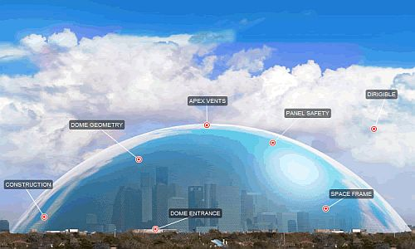

There is a worldwide pandemic killing millions of people...
The only way to survive is in a dome…….
YOU are in charge...
HOW WILL YOU SURVIVE IN A DOME FOR TWO YEARS?

Name _________________________________

Big Question
“What do we need to put into the Dome and why?”
Details:
- The Dome needs to exclude all material from outside except sunlight as the virus is thought to be able to survive on non-living material for a significant time.
- The Dome will be 2Km in diameter.
- Only healthy non-infected people will be allowed to live there. You will decided who and how many.

Presentation (Big Question)
Your presentation will be:
- A model dome built on a board or wood.
- A single PowerPoint slide with links to other pages explaining the different features of your Dome and why you have chosen them.

Booklet:
This booklet will help you gather information and design your dome. It includes key ideas you will need to think about to make this dome a success.

If the living things in the Dome are to be kept alive
Mrs Gren needs to be kept happy.

Key idea 1: How would plants and animals in the Dome get their food (Nutrition)?
?
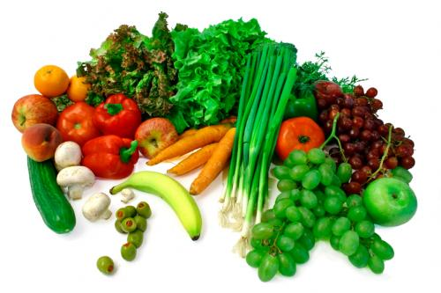
- What foods should you have in your dome? Use this food pyramid to work out the types of food you should include.
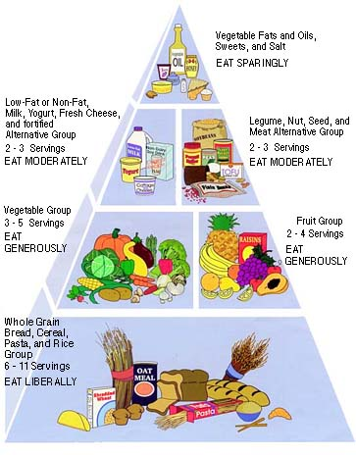
?
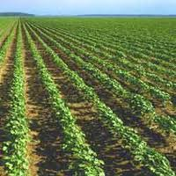
..............................................................................................................................................................................................................................................................................................................................................................................................................................................................................................................................................................................................................................................................................................................................................................................................................................................................................................................................................................................................................................................................................................................................................................................................................................................
- How will you ensure these foods are available to the people in the dome?
............................................................................................................................................................................................................................................................................................................................................................................................................................................................................................................................................................................................................................................................................................................................................................................................
- How do plants grow? Explain the process of Photosynthesis by drawing a diagram and explaining what is happening.

What is the word equation for photosynthesis?
_____________________ + _____________________ ^{sunlight} ________________+ _______________
How can you help plants to grow?
....................................................................................................................................................................................................................................................................................................................................................................................................................................................................................................................................................................................
We are experimenting with different things to find out what is the most effective way to help plants grow fast.
Write a method out to investigate this ........................................................................................................................................................................................................................................................................................................................................................................................................................................................................................................................................................................................................................................................................................................................................................................................................................................................................................................................................................................................................................................................................................................................................................................................................................................................................................................................................................................................................................................................................................................................................................................................................................................................................................................................................................................................................................................................................................................................................................
Conclusion: (what is the best way to grow plants and how do you know)
...........................................................................................................................................................................................................................................................................................................................................................................................................................................................................................................................................................................................................................................................................................................................................................................................................................................................................................................................................................................................

Key idea 2: Water is vital for all living things so how do we make sure they all get enough in the Dome?
Draw or find a labelled picture of the water cycle.

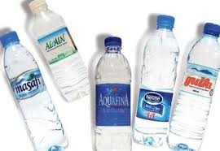
Where are your water sources in the outside world?
............................................................................................................................................................................................ ............................................................................................................................................................................................ ............................................................................................................................................................................................ ............................................................................................................................................................................................
What are your water sources in the dome?
............................................................................................................................................................................................ ............................................................................................................................................................................................ ............................................................................................................................................................................................ ............................................................................................................................................................................................

How will you ensure you have enough water?
............................................................................................................................................................................................ ............................................................................................................................................................................................ ............................................................................................................................................................................................ ............................................................................................................................................................................................

Key idea 3: All living things are made up of carbon (that’s why there is so much fuss about it now; we have changed our Biosphere too much.)

- Draw or find a labelled picture of the carbon cycle.

- Write a simple word equation for respiration in animals and plants (at night).
_____________________ + _____________________ ________________+ _______________

Compare this with photosynthesis equation (key idea 1)
- What would happen to the carbon dioxide and oxygen levels if we had:
- Too many animals
......................................................................................................................................................................................................................................................................................................................................................
- Too many plants
......................................................................................................................................................................................................................................................................................................................................................

Key idea 4: How do we get the energy we need to live in the dome?
What actual energy do we need to live in the Dome? How will you keep warm? Will you need electricity?
Fill in the table below giving a positive and negative about each energy resource. Which energy resource will you use and why?
Energy resource | Positive | Negative | Use?
Wind
Hydroelectric
Geothermal
Solar
Fossil fuel
Nuclear

Which form of power generation would you use in your dome?
............................................................................................................................................................................................
Why would you use that type?
............................................................................................................................................................................................ ............................................................................................................................................................................................
What else could you put in your dome to ensure people could happily live in there for 2 years?
............................................................................................................................................................................................ ............................................................................................................................................................................................ ............................................................................................................................................................................................ ............................................................................................................................................................................................ ............................................................................................................................................................................................ ............................................................................................................................................................................................ ............................................................................................................................................................................................ ............................................................................................................................................................................................ ............................................................................................................................................................................................
Key idea 5: Who will live in your dome? How will you choose? Visitors allowed?
- How are you going to make the decisions about who gets to live there and who misses out? How many people?
............................................................................................................................................................................................ ............................................................................................................................................................................................ ............................................................................................................................................................................................ ............................................................................................................................................................................................ ............................................................................................................................................................................................ ............................................................................................................................................................................................ ............................................................................................................................................................................................ ............................................................................................................................................................................................ ............................................................................................................................................................................................ ............................................................................................................................................................................................ ............................................................................................................................................................................................ ............................................................................................................................................................................................ ............................................................................................................................................................................................
While no one is usually allowed to visit the Dome, if there is an emergency it has been suggested we could have a Quarantine Area at the entrance. How would you add this to your Dome? What would the rules be? For example, how long are they allowed in and what would happen before they are allowed in?
- Fill in the table below about microbes.
Type of microbe | Picture | Features | Useful or harmful | Examples
Bacteria

Virus

Fungi

Part 6: Floor plan
Now you need to start working on a floor plan for your dome. What will you include? Where will everything be? How will you fit it all in? Remember you have a 5km diameter circle for your dome to fit in.
Draw out some floor plans so you can decide on a final and start building the model of your dome.
What materials do you need to start making your dome?
............................................................................................................................................................................................ ............................................................................................................................................................................................ ............................................................................................................................................................................................ ............................................................................................................................................................................................ ............................................................................................................................................................................................ ............................................................................................................................................................................................ ............................................................................................................................................................................................ ............................................................................................................................................................................................
Websites to help you:
University of Arizona experimental Biosphere 2 (World’s largest Biosphere): http://www.b2science.org/

There is some good information on:
http://en.wikipedia.org/wiki/Biosphere_2#Pilot_experiments

Montreal in Canada has an awesome Dome for education:
http://www2.ville.montreal.qc.ca/biodome/mvc/integrationen/content.html

You can build a mini Biosphere:
http://www.pbs.org/safarchive/4_class/45_pguides/pguide_704/4574_hiddeep.html
http://nextbigfuture.com/2008/04/very-cheap-dome-protection-from-nuclear.html

Experiments on CO_{2 :}
http://www.pbs.org/safarchive/4_class/45_pguides/pguide_601/4561_planet.html

Human Trials:
Jane Poynter: www.janepoynter.com and video of Biosphere 2: www.ted.com/talks/jane_poynter_life_in_biosphere_2.html

Information on microbes:
http://www.e-bug.eu/lang_eng/primary_pack/downloads/UK%20Junior%20Pack%20Complete.pdf

